# Developer Guide

**JWebSocket**

**Arduino Remote Control Demo**

**Dariel Noa Graverán**

**Version history?**

1. **Overview**

The Arduino Remote Control Demo is an application developed with the jWebSocket framework and the Arduino hardware platform. The application is based on a plug-in, which sends and receives data of the micro-controller of Arduino´s Platform. The source code is structured in three parts: the web application controller (what s this? this is the client?), the jWebSocket server and the microcontroller of circuits of the Arduino Platform. The application uses an event-driven programming. It promotes the use of libraries like (“like” ?) Raphael (does it use it or not? Please explain.) for the treatment of vector images on the web, jQuery for access and animations of the HTML elements and, RxTx library for send and receive data from USB port

1. **Infrastructure solution**

The solution is built following the model that the EventPlugIn provides in the jWebSocket Server. The EventPlugIn can listen to events that are released when the Micro-controller of Arduino´s circuit sends data to the server. The following is the diagram of components for a better understanding:

**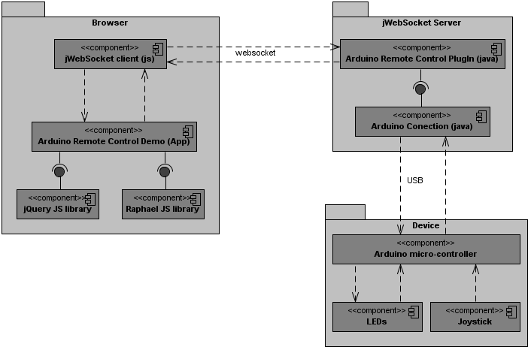**

|  |
| --- |
|  |

*Ref. to Fig.1: Component Diagram*

**Description:**

* Arduino Remote Control Demo Application uses the libraries, JavaScript, jQuery and Raphael (ah, it really uses it :-).
* Arduino Remote Control Demo application sends and receives information through JavaScript Client Library of jWebSocket.
* The jWebSocket Client communicates with jWebSocket Server through Websocket protocol.
* jWebSocket Server contains Arduino RemoteControlPlugIn, who receives and sends data to the controller application.
* The Arduino Connection component is contained in Arduino RemoteControlPlugIn. This component is who sends and receives data from the micro-controller of Aduino´s circuit directly.
* Micro-controller of Arduino´s circuit has connected a kit contains 4 LEDs, and a joystick.

1. **Requirements for use**

The application has the advantage to work on Linux, Windows and Mac OS, but for its total operation requires the following:

* OpenJDK 1.7 or higher. Should work with Java 1.6 and Java 1.7 as well! Does it?
* RxTx native libraries copied into the binaries folder of the Java Virtual Machine(JVM). See Administrator Guide.
* Micro-controller of circuit of the Arduino hardware platform.
* Web browser with support for Websocket protocol. Older browsers are also supported, remind the flash.bridge as well as our comet fallback!

In the xml file associated with the configuration of the Arduino RemoteControlPlugIn, the developer must specify which port will be used for connecting the Micro-controller of Arduino´s circuit. Again, how does the developer know that (is listed in the Arduino App, but this is not explained here, please add!)

To download the controller packages application, the jWebSocket Server, the native libraries for access to serial port and the containing program of Micro-controller of Arduino´s circuit, please refer to the URL: <http://jwebsocket.org/download/>

1. **Modularization of the application**

**Server side**

|  |  |
| --- | --- |
| Solution Name | Arduino Remote Control Demo |
| Locationof the sources inthe SVN server: | <https://jwsdev.org:9443/svn/jWebSocket/branches/jWebSocket-1.0/jWebSocketPlugIns/jWebSocketArduinoPlugIn/> |
| SVNbranch: | jWebSocket-1.0 |
| Mavendependencies: | <dependency>  <groupId>org.jwebsocket</groupId>  <artifactId>jWebSocketServer</artifactId>  <version>1.0</version>  </dependency>  <dependency>  <groupId>org.rxtx</groupId>  <artifactId>rxtx</artifactId>  <version>1.2.7</version>  </dependency>  In the text you were talking about “Raphael” how is that imported/used, please explain! |
| JAR module: | ArduinoRemoteControl-1.0.jar |
| Packagestructure | Base namespace  org.jwebsocket.plugins  /svn/jWebSocket.dev/thesis/Arduino_Remote_Control_Demo_Dariel/Documentation/Images/Structure_Package_Server.PNG |
| org.jwebsocket.plugins.arduino:  Contains the Arduino RemoteControlPlugIn which sends and receives data to the controller application. | |
| org.jwebsocket.plugins.arduino.connection:  It contains the elements necessary for establish the serial communication with the Micro-controller of Arduino´s circuitdirectly. | |
| org.jwebsocket.plugins.arduino.conecction.event:  In this package the event who starts when the data is sent from the Micro-controller of Arduino´s circuit to the jWebSocket Server is implemented. | |
| org.jwebsocket.plugins.arduino.event.c2s:  This package contains the definition of the events which are fired by the controller application when they are noticed by the jWebSocket Server. Weird English, please check if this was your original meaning. | |
| org.jwebsocket.plugins.arduino.event.s2c:  This package contains the definition of the events which start the launch from jWebSocket Server when are heard by the application controller. | |
| org.jwebsocket.plugins.arduino.util:  This package contains utilities to run the application. It contains classes for the treatment of data that is sent from the microcontroller. | |

**Client Side**

The controller application, in addition to elements forming part of the HTML markup language, has a JavaScript structure, constituting the burden of implementation on the client. The JavaScript code is divided into several files that are presented to below:

* Init.js: This file contains methods for connecting to the jWebSocket server, the method for send a command from the controller to the Micro-controller of Arduino´s circuit and initializes the design elements that are part of the graphical interface of the controller application.
* jwsRemoteControl.js: Contains the functions of the demo application: functions that rely on design elements to show status of the LEDs, and another function that displays the coordinates of the joystick using an object created with the library Raphael. Here still not clear what “Raphael” is and where it is used.

The controller application also uses JavaScript libraries in order to facilitate the work in some aspects; the libraries used are the following.

* jWebSocket.js: This library is responsible to establish the connection between the controller applicationand the jWebSocket server.
* jwsEventsPlugIn.js: Extension of jWebSocket client library that defines the event model which is based on the Arduino Remote Control Demo.
* jwsCache.js: Library to manage the web browser cache.
* jQuery.js: JavaScript library has multiple functions, including access to DOM elements, effects, Ajax requests (we need AJAX? Not really, or?) and event handling.
* Raphael.js: JavaScript library for the treatment of vector images on the Web, is used in the application in order to show the movements of the joystick.  
  Ahhh, At the end I noticed it is a client library ;-) This is confusing the reader, please expose that clearly.

1. **Source code structure**

**Server side**

The following figure shows the directory structure in detail containing the jWebSocket server code including all java classes with which account the application. The classes are distributed in packets that were previously described, and which in turn are associated with directories shown below.

**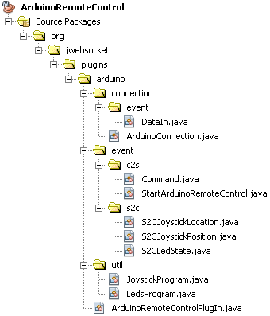**

|  |
| --- |
|  |

*Ref. to Fig.2: Directory Structure Server*

The following figure shows the root directory of the application source code, as well as describing those directories and files for better understanding.

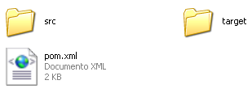

|  |
| --- |
|  |

*Ref. to Fig.3: Server root directory*

**Description**

* src: The directory is all the source code of the application, it includes the main/ java and then a directory structure that matches the one shown in Figure 2.
* target: The directory temporarily stores the compiled source code, its content is not included in the version control.
* pom.xml: Configuration File ArduinoRemoteControl module used by Maven. This file defines among other features, dependencies, in this case and jWebSocket RxTx libraries.

**Client side**

The following figure shows where the source code distributed web application controller.

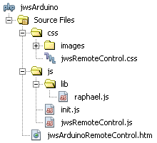

|  |
| --- |
|  |

*Ref. to Fig.4: Directory structure of the client application*

* 1. **packageStructure in the server side**

*org.jwebsocket.plugins.arduino* package contains the following class

|  |  |
| --- | --- |
| Class | Description |
| ArduinoRemoteControlPlugIn | This class represents the plug-in used to release and listen to events, which serves the communication with the web application controller. |

Detailed description of the methods:

|  |  |  |
| --- | --- | --- |
| Class: org.jwebsocket.plugins.arduino.ArduinoRemoteControlPlugIn | | |
| Type | **Method** | **Description** | |
| org.jwebsocket.plugins.arduino.connection.  ArduinoConnection | getArduinoConnection() | This method returns the object that connects directly to the Micro-controller of Arduino´s circuit. | |
| void | Initialize() | Inherited method that initializes the connection to the microcontroller circuit. | |
| void | processEvent(org.jwebsocket.eventmodel.event.C2SEvent aEvent, org.jwebsocket.eventmodel.observable.ResponseEvent aResponseEvent) | Inherited method that processes events that are launched from the application controller. | |
| void | sendJoystickPosition(java.lang.Integer aX, java.lang.Integer aY) | This method throws an event to the web application controller, which contains the coordinates of the joystick. | |
| void | sendLedState(java.lang.Boolean aBlue, java.lang.Boolean aRed, java.lang.Boolean aGreen, java.lang.Boolean aYellow) | This method raises an event to the controller application, which contains information on the status of the LEDs. | |
| void | setArduinoConnection(org.jwebsocket.plugins.arduino.connection.  ArduinoConnection aArduinoConnection) | This method changes the object that will connect to the microcontroller circuit. | |

*org.jwebsocket.plugins.arduino.connection* package contains the following class:

|  |  |
| --- | --- |
| Class | Description |
| ArduinoConnection | Through this class the plug-in can communicate with the micro-controller circuits of the Arduino hardware platform, the class has methods to send data, and event listener using the data you send the circuit to the USB port. |

Detailed description of the methods:

|  |  |  |
| --- | --- | --- |
| Class: org.jwebsocket.plugins.arduino.connection.ArduinoConnection | | |
| Type | **Method** | **Description** | |
| void | closePort() | Free USB port that is configured to communicate with the microcontroller. | |
| java.lang.Integer | getDataBits() | Gets the number of bits of data, which set up the port, the default is 8 bits. | |
| java.lang.Integer | getDebugRate() | Gets the port connection speed, the default is 9600 bps. | |
| java.lang.Integer | getParity() | Get parity with the connection to be made, the default value is 0, indicating no parity. | |
| java.lang.String | getPortName() | Gets the name of the USB port, which should be connected to the microcontroller circuit. | |
| java.lang.Integer | getStopBits() | Returns the stop bits associated with the connection via the USB port, the default value is 1. | |
| java.lang.Integer | getTimeOut() | Gets the time in milliseconds to wait for connection to the USB port, the default will be 2000 milliseconds. | |
| void | init() | Initializes the connection to the USB port, with all the settings needed to communicate. | |
| void | sendCommand(java.lang.String aCmd) | Sends data to the microcontroller circuit, this method sends text strings. | |
| void | sendCommand(java.lang.Integer aCmd) | Overloaded method that sends commands to the microcontroller circuit, which specializes in sending numeric data. | |
| void | serialEvent(gnu.io. SerialPortEvent aEvent) | Inherited method which is executed when the circuit sends data to the USB port, an event listener method that contains the data sent from the circuit. | |
| void | setDataBits(java.lang.Integer aDataBits) | Changes the data bits to be sent by the USB port. | |
| void | setDebugRate(java.lang.Integer aDebugRate) | Changes the speed of connection to the USB port. | |
| void | setParity(java.lang.Integer aParity) | Changes the parity. | |
| void | setPortName(java.lang String aPortName) | Changes the port. | |
| void | setStopBits(java.lang.Integer aStopBits) | Changes the stop bit. | |
| void | setTimeOut(java.lang.Integer aTimeOut) | Changes time out connection. | |

*org.jwebsocket.plugins.arduino.connection.event* package contains the following class:

|  |  |
| --- | --- |
| Class | Description |
| DataIn | The class defines an event that is triggered when the micro-controller circuit sends data to the USB port. The main function of this event is to be heard by the plug-in ArduinoRemoteControlPlugIn, as it contains the data received from the circuit, which is then sent through another event to the Web application controller. |

Detailed description of the methods:

|  |  |  |
| --- | --- | --- |
| Class: org.jwebsocket.plugins.arduino.connection.event.DataIn | | |
| Type | **Method** | **Description** | |
| org.jwebsocket.plugins.arduino.connection.event.DataIn | DataIn(java.lang.String aData) | Constructor for the class entering data to the event. | |
| java.lang.String | getData() | This method extracts the event data. | |

*org.jwebsocket.plugins.arduino.event.c2s* package contains the following class:

|  |  |
| --- | --- |
| Class | Description |
| Command | This class tdefines the event which launches the web application controller to send information to microcontroller circuit. This event is processed by the plug-in ArduinoRemoteControlPlugIn. |
| StartArduinoRemoteControl | This class defines the event which is launched from the web application controller, when it starts. Once the event is fired by the ArduinoRemoteControlPlugIn, it is sent to the controller application status LEDs. |

Detailed description of the methods:

|  |  |  |
| --- | --- | --- |
| Class: org.jwebsocket.plugins.arduino.event.c2s.Command | | |
| Type | **Method** | **Description** | |
| java.lang.Integer | getCmd() | Method that allows the ArduinoRemoteControlPlugIn to extract the event data and then send them to the microcontroller circuit. | |

|  |  |  |
| --- | --- | --- |
| Class: org.jwebsocket.plugins.arduino.event.c2s.StartArduinoRemoteControl | | |
| Type | **Method** | **Description** | |
| This event does not have any functionality, since that will only serve to notify the application started controlling | | | |

*org.jwebsocket.plugins.arduino.event.s2c* package contains the following class:

|  |  |
| --- | --- |
| Class | Description |
| S2CJoystickPosition | This class defines the event responsible for sending the application to the coordinates of the joystick controller. |
| S2CLedState | This class defines the event responsible for sending the application to the coordinates of the joystick controller. |

Detailed description of the methods:

|  |  |  |
| --- | --- | --- |
| Class: org.jwebsocket.plugins.arduino.event.s2c.S2CLedState | | |
| Type | **Method** | **Description** | |
| org.jwebsocket.plugins.arduino.event.s2c. S2CLedState | S2CLedState(java.lang.Boolean aBlue, java.lang.Boolean aRed, java.lang.Boolean aGreen, java.lang.Boolean aYellow) | This class constructor allows to introduce the data will contain the event and then send it to the application controller. | |
| java.lang.Boolean | getBlue() | Returns the status of the blue LED, on = true and false = off. | |
| java.lang.Boolean | getRed() | Returns the status of the red LED, on = true and false = off. | |
| java.lang.Boolean | getGreen() | Returns the status of the green LED, on = true and false = off. | |
| java.lang.Boolean | getYellow() | Returns the status of the yellow LED, on = true and false = off. | |
| void | writeToToken(org.jwebsocket.token. Token token) | Inherited method which is called from the jWebSocket framework. Used to convert the data to Token, preparing the event for shipment. | |

|  |  |  |
| --- | --- | --- |
| Class: org.jwebsocket.plugins.arduino.event.s2c.S2CJoystickPosition | | |
| Type | **Method** | **Description** | |
| org.jwebsocket.plugins.arduino.event.s2c. S2CJoystickPosition | S2CJoystickPosition(java.lang.Integer aX, java.lang.Integer aY) | This class constructor allows to introduce the data will contain the event and then send it to the application controller. | |
| java.lang.Integer | getmX() | Returns the x value of the event stored position. | |
| java.lang.Integer | getmY() | Returns the y value of the event stored position. | |
| void | writeToToken(org.jwebsocket.token. Token token) | Inherited method which is called from the jWebSocket framework. Used to convert the data to Token, preparing the event for shipment. | |

*org.jwebsocket.plugins.arduino.util* package contains the following class:

|  |  |
| --- | --- |
| Class | Description |
| JoystickProgram | This class contains functions to process the data being sent from the circuit, referring to the coordinates of the joystick. |
| LedsProgram | This class contains functions to process the data being sent from the circuit, concerning the status of the LEDs. |

Detailed description of the methods:

|  |  |  |
| --- | --- | --- |
| Class: org.jwebsocket.plugins.arduino.util.JoystickProgram | | |
| Type | **Method** | **Description** | |
| java.lang.Integer[] | refineValue(java.lang.Integer aX, java.lang.Integer aY) | This method limits the coordinate values ​​to send to the controller application. | |
| java.lang.Integer[] | treatValues(java.lang.String aData) | By this method it is possible to transform the data sent by the micro-controller regarding the coordinates, returns an array, where positions 0 y1 are the values ​​of x, y respectively. | |

|  |  |  |
| --- | --- | --- |
| Class: org.jwebsocket.plugins.arduino.util.LedsProgram | | |
| Tipo | **Método** | **Descripción** | |
| java.lang.Boolean[] | parseLedState(java.lang.Integer aState) | This method transforms the data sent by the Micro-controller of Arduino´s circuit with respect to the state of the LEDs, as a parameter an integer between 0 and 15, the number indicates that LED is on and / or reflected off a binary number 4 bits, the return of the method is an array with 4 positions representing each of the LEDs, in the order blue, red, green and yellow on true, false off. | |

* 1. **Source code structure in the client side**

The web application controller, consists of web programming elements. These are HTML pages, CSS files and JavaScript files. Below the functions of each JavaScript file are shown, considering the weight of the client application:

|  |  |  |
| --- | --- | --- |
| File: init.js | | |
| Type | **Function** | **Description** | |
| void | connect() | Opens the connection to the server jWebSocket, and generates the plug-in ArduinoRemoteControl, which will launch the events. | |
| void | disconnect() | Closes the connection to the jWebSocket server. | |
| void | Init() | Initializes the design elements and then calls the connect () method described above. | |
| void | initCanvas() | Create an SVG image associated with an HTML element, to represent the movements of the joystick, this method uses the Raphael library. | |
| void | registerEvents() | Records events of the elements of level design mouse (onClick). | |
| void | sendCommand(aCmd) | Function that supports plug-in generated in the controller application to launch to the server jWebSocket the Command event. The aCmd is an integer parameter, used the numbers 49, 50, 51 and 52 for driving the LEDs blue, red, green and yellow respectively. | |
| void | startArduinoRemoteControl() | Makes a function call registerEvents () and throws to the server StartArduinoRemoteControl jWebSocket the event, telling the server that started the application controller. | |

|  |  |  |
| --- | --- | --- |
| File: jwsRemoteControl.js | | |
| Type | **Function** | **Descripction** | |
| void | changePosition(aX , aY) | The function takes care of the application display controller joystick movements. | |
| void | changeledsStatus(aBlue, aRed, aGreen, aYellow) | The role is responsible for representing the state of the LEDs, using CSS classes and attributes. Receives 4 Boolean parameters represent the state of each of the LEDs. | |

* 1. **Programing the micro-controller**

Programming the Micro-controller of Arduino´s circuit, is another important aspect in the process of application development. The codes are developed with an Arduino IDE is part of the hardware platform. The IDE allows you to create programs and then upload them to the circuit. Before this process must be configured in the IDE, the port will be connected to the circuit and the circuit model. An Arduino program consists of two main functions:

* setup(): This function typically sets the digital pin mode, in or out, in the case of the application, set pins 4, 7, 8 and 12 digital output, set the baud rate to 9600 bps and configure the analog pins 0 and 1 for the coordinates of the joystick.
* loop(): This function is performed as a cycle, it is practically the entire program that will control the LEDs and will monitor the joystick.

In addition to the aforementioned functions, the program contains other to be described below:

|  |  |  |
| --- | --- | --- |
| File: rc\_demo.pde | | |
| Type | **Function** | **Description** | |
| void | changeLedState() | The function works with Boolean variables associated with each LED which prepares a variable with an integer from 0 to 15 and then sent via the USB port jWebSocket server. | |
| int | treatValue(int data) | Because the values ​​produced by the joystick is very sensitive, it is necessary to treat jWebSocket sent to the server, this function takes care of the problem. | |
| void | changePosition(int x, int y) | The function is executed when the joystick changes position jWebSocket sent to the server through the USB port the coordinates of the joystick, it sends a text string containing the values ​​x, and the text string is identified by start the character 'J'. | |

This is not enough here! It’s a good start, but the reader will expect the listing for the micro controller and a description of it, to enable him to modify it according to his needs or use it as a template for own developments. Please extend this chapter into this direction.

1. **Libraries and tools used**

* jWebSocket Framework, LGPL.
* Arduino Hardware platform, CC license (Creative Commons).
* jQuery JavaScript library, GPL v2.
* Raphael library, MIT License.
* RxTx library, GPL v2.1
  1. **Maven Configuration**

The Arduino Remote Control module has a Maven pom.xml file, in which in addition to other parameters the version of the module and dependencies of the module are defined. Dependencies are an important aspect in projects created with Maven. In the following picture you see how the dependencies are configured for better understanding.

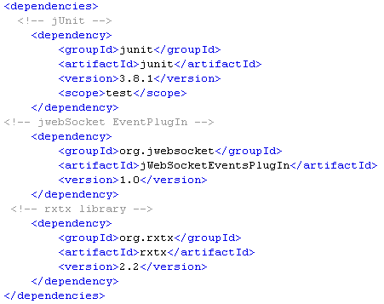



*Ref. to Fig.5: Dependencies in the pom.xml file*

The repository operated by the last unit shown in Figure 5, depending on the repository may not be available, if this happens you can change the version of the library by 2.1.7, this would not alter the operation of the application. However, it should be noted that by changing the version of the library will also change the version of the native library copied into the / bin folder of JDK.

Please also add the required “repositories” section if the dependencies cannot be resolved normally. It should be ensure that the libraries always can be loaded after we deployed a new version!

1. **Hardware**

For remote control of devices, you must have a micro-controller circuit of the Arduino platform, the application was developed on the microcontroller Arduino Mega ADK, however you can use any other circuit of the platform Arduino Duemilanove, Arduino Diecimila or similar. Arduino circuits have a connection to the computer via the USB port, but older models are connected by the RS232 port.

To jump-start the application besides the micro-controller circuit you must have, the following:

* Four LEDs, blue, red, green and yellow.
* A joystick with two connections (x, y).
* A USB cable.
* A module TinkerKit (Optional).

For more information on Micro-controller of Arduino´s platform, visit the site: <http://arduino.cc> .

1. **Continuous Improvement**

The jWebSocket server console recorded in its logs what happens, e.g. when you throw an event, and when listening to an event, to achieve faster data processing on the server, the developer can go to server configuration and disable these logs (if you write about that, you need to explain how too!). In the Web application this is similar, by default the logs are disabled, because these events display all the console application, is costly.

1. **Configuración de la aplicación (English please)**

The application is subject to the settings that you can make the jWebSocket working environment, however you need to specify which port is connected to the Arduino circuit and for this we must access the file located at:

|  |
| --- |
| *$JWEBSOCKET\_HOME/conf/EventsPlugIn/rc-application/app-plugins/rc.xml* |

In rc.xml file, specifying all the details that has the plug-in ArduinoRemoteControlPlugIn, to configure the port should take into account that operating system will work. In Windows the port would be COM0, ....., COM4, on Linux it may be /dev/tty/USB0, /dev/tty/USB1 or similar and probably MacOS /dev/tty.usbserial-1B1.

Please describe how to figure out the available ports. For instance by the Arduino application. This definitly needs to be explained as an essential tool for the installation and the operation of your plug-in!

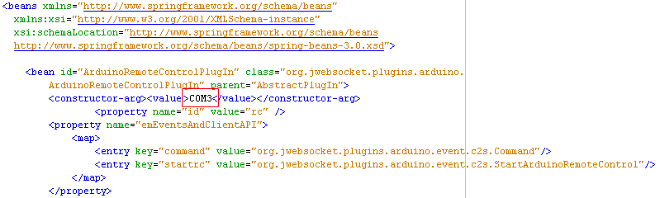

|  |
| --- |
|  |

*Ref. to Fig.6: Port settings in the rc.xml file*